# Perth Modern School

### Semester One Examination, 2016

### Question/Answer Booklet

# MATHEMATICS

**SOLUTIONS**

**SPECIALIST**

**UNIT 1**

## Section Two:

## Calculator-assumed

|  |  |  |  |  |  |  |  |  |
| --- | --- | --- | --- | --- | --- | --- | --- | --- |
| Student Number: In figures |  |  |  |  |  |  |  |  |

In words

Your name

## Time allowed for this section

Reading time before commencing work: ten minutes

Working time for section: one hundred minutes

## Materials required/recommended for this section

***To be provided by the supervisor***

This Question/Answer Booklet

Formula Sheet (retained from Section One)

***To be provided by the candidate***

Standard items: pens (blue/black preferred), pencils (including coloured), sharpener, correction fluid/tape, eraser, ruler, highlighters

Special items: drawing instruments, templates, notes on two unfolded sheets of A4 paper, and up to three calculators approved for use in the WACE examinations

## Important note to candidates

No other items may be taken into the examination room. It is **your** responsibility to ensure that you do not have any unauthorised notes or other items of a non-personal nature in the examination room. If you have any unauthorised material with you, hand it to the supervisor **before** reading any further.

## Structure of this paper

|  |  |  |  |  |  |
| --- | --- | --- | --- | --- | --- |
| Section | Number of questions available | Number of questions to be answered | Working  time (minutes) | Marks available | Percentage of exam |
| Section One:  Calculator-free | 7 | 7 | 50 | 49 | 35 |
| Section Two:  Calculator-assumed | 13 | 13 | 100 | 102 | 65 |
|  | | | **Total** | 151 | 100 |

## Instructions to candidates

1. The rules for the conduct of examinations are detailed in the school handbook. Sitting this examination implies that you agree to abide by these rules.
2. Write your answers in this Question/Answer Booklet.
3. You must be careful to confine your response to the specific question asked and to follow any instructions that are specified to a particular question.
4. Spare pages are included at the end of this booklet. They can be used for planning your responses and/or as additional space if required to continue an answer.

* Planning: If you use the spare pages for planning, indicate this clearly at the top of the page.
* Continuing an answer: If you need to use the space to continue an answer, indicate in the original answer space where the answer is continued, i.e. give the page number. Fill in the number of the question that you are continuing to answer at the top of the page.

1. **Show all your working clearly**. Your working should be in sufficient detail to allow your answers to be checked readily and for marks to be awarded for reasoning. Incorrect answers given without supporting reasoning cannot be allocated any marks. For any question or part question worth more than two marks, valid working or justification is required to receive full marks. If you repeat any question, ensure that you cancel the answer you do not wish to have marked.
2. It is recommended that you **do not use pencil**, except in diagrams.
3. The Formula Sheet is **not** to be handed in with your Question/Answer Booklet.

Section Two: Calculator-assumed 65% (102 Marks)

This section has**thirteen (****13)** questions. Answer **all** questions. Write your answers in the spaces provided.

Working time for this section is 100 minutes.

Question 8 (5 marks)

In the diagram below, AB is a tangent to the circle and .

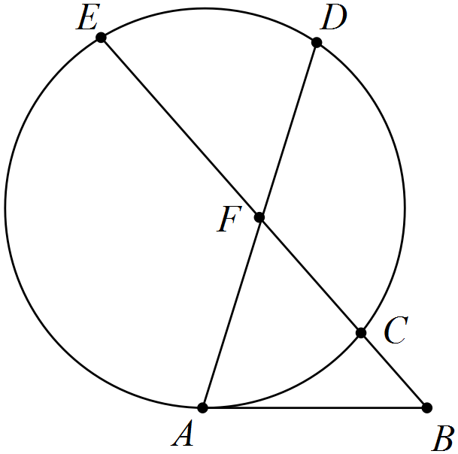

If  and , determine the lengths of

(a) AB. (2 marks)

|  |
| --- |
| **Solution** |
|  |
| **Specific behaviours** |
| ✓ uses secant-tangent relationship  ✓ calculates length |

(b) CF. (1 mark)

|  |
| --- |
| **Solution** |
|  |
| **Specific behaviours** |
| ✓ calculates length |

(c) AF. (2 marks)

|  |
| --- |
| **Solution** |
|  |
| **Specific behaviours** |
| ✓ uses product of chord intervals  ✓ calculates length |

Question 9 (7 marks)

Two forces act on body. The first has magnitude 250 N and acts in direction 240° and the second has magnitude 410 N and acts in direction 170°.

(a) Determine the resultant of the two forces. (4 marks)

|  |
| --- |
| **Solution** |
| Resultant has magnitude 548.4 N in direction 195.4°. |
| **Specific behaviours** |
| ✓ diagram  ✓ uses cosine rule to determine magnitude  ✓ uses sine rule to determine angle  ✓ states resultant as magnitude and direction |

(b) The work done, in joules, by a force in moving a body is the scalar product of the force, in newtons, and the displacement, in metres. Determine the total work done by the two forces, to the nearest 100 joules, if the body moves 45 metres in direction 215°. (3 marks)

|  |
| --- |
| **Solution** |
|  |
| **Specific behaviours** |
| ✓ determines angle between directions  ✓ uses scalar product  ✓ rounds correctly |

Question 10 (8 marks)

(a) Use a counterexample to demonstrate that each of following statements are false.

(i) . (2 marks)

|  |
| --- |
| **Solution** |
| If , then  but  and so statement is false. |
| **Specific behaviours** |
| ✓ supplies values for counterexample  ✓ uses values to show statement is false |

(ii) If f(n) = n2 + n + 1 then  is always prime. (2 marks)

|  |
| --- |
| **Solution** |
| f(5) = 52 + 5 + 5  = 5(5 + 1 + 1)  Since f(5) is clearly not prime, then the statement is false |
| **Specific behaviours** |
| ✓ supplies value of n so that  is not prime  ✓ shows why supplied value is not prime |

(b) The statement 'if a natural number is a multiple of 4 and 5 then the natural number is a multiple of 20' is true.

(i) Write the contrapositive of the statement and explain whether or not the contrapositive is also true. (2 marks)

|  |
| --- |
| **Solution** |
| If a natural number is not a multiple of 20 then it is not a multiple of 4 and 5.  This is true, as contrapositive always true if original statement true. |
| **Specific behaviours** |
| ✓ writes contrapositive  ✓ states with reason that it is true |

(ii) Write the converse of the statement and explain whether or not the converse is also true. (2 marks)

|  |
| --- |
| **Solution** |
| If a natural number is a multiple of 20 then it is a multiple of 4 and 5.  This is true, as if a number has a factor of 20 then it will also have factors of 4 and 5. |
| **Specific behaviours** |
| ✓ writes converse  ✓ explains converse is true |

Question 11 (8 marks)

Fifteen children at a summer camp are to be divided into two groups of nine and six.

(a) Determine the number of different groupings. (2 marks)

|  |
| --- |
| **Solution** |
| groupings |
| **Specific behaviours** |
| ✓ uses combinations  ✓ calculates correct number |

(b) Determine how many groupings are possible if the two youngest children must be in the same group. (3 marks)

|  |
| --- |
| **Solution** |
|  |
| **Specific behaviours** |
| ✓ calculates ways using larger group  ✓ calculates ways using smaller group  ✓ calculates total number of groupings |

(c) If ten of the fifteen were girls, in how many of the different groupings do both groups contain more girls than boys? (3 marks)

|  |
| --- |
| **Solution** |
| Large group must have 6G3B or 5G4B (so that other has 4G2B or 5G1B). |
| **Specific behaviours** |
| ✓ determines required groupings  ✓ calculates first grouping  ✓ calculates second grouping and total |

Question 12 (7 marks)

Vector a has magnitude 6 units and acts on a bearing of 310°. Vector b has magnitude 12 units and acts on a bearing of 070°.

(a) Determine the magnitude and direction of . (4 marks)

|  |
| --- |
| **Solution** |
|  |
| **Specific behaviours** |
| ✓ sketches diagram to show addition of multiples of vectors  ✓ uses cosine rule to determine magnitude  ✓ uses sine rule to determine angle  ✓ states direction as bearing |

(b) Determine the value of the constant k if the direction of  is due north. (3 marks)

|  |
| --- |
| **Solution** |
|  |
| **Specific behaviours** |
| ✓ sketches diagram  ✓ determines required magnitude  ✓ determines k |

Question 13 (9 marks)

(a) AB is a diameter of a circle centre O. C is a point on the circumference. D is a point on AC such that OD bisects . Prove that OD is parallel to BC. (4 marks)

|  |
| --- |
| **Solution** |
|  |
| **Specific behaviours** |
| ✓ shows information using diagram  ✓ determines angle ABC  ✓ determines angle BCO  ✓ uses alternate angles to explain parallel |

Also ∠AOD = 90 (mid chord)

∠ACB = 90 Angle in semi Circle

Therefore OD ll BC Cointerior angles supplementary

(b) In the diagram below, FCG is a tangent to the circle ABC. BD bisects , CD bisects , BE bisects  and CE bisects . If  and , determine the ratio, in simplest form, of . (5 marks)

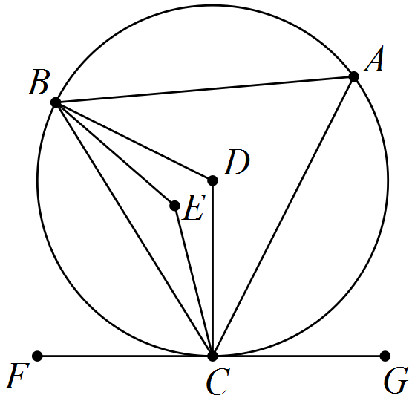

|  |
| --- |
| **Solution** |
| ABC is isosceles and angle bisectors will intersect on line of symmetry and . |
| **Specific behaviours** |
| ✓ explains ABC isosceles and results  ✓ uses angle in opposite segment  ✓ determines DBC and EBC  ✓ determines BAC, BDC and BEC  ✓ determines simplified ratio |

Question 14 (9 marks)

Points O, P, Q and R have position vectors , ,  and .

(a) Determine the value of y if . (2 marks)

|  |
| --- |
| **Solution** |
|  |
| **Specific behaviours** |
| ✓ writes magnitude equation  ✓ states both +ve and -ve solutions |

(b) Determine the value of x if $\vec{OQ}$ $\vec{QR}$. (3 marks)

|  |
| --- |
| **Solution** |
| **QR** = <(2-x),(-5 - -1)>  = <(2-x),(-4)>  <x,-1> •<(2-x),(-4)> = 0  2x – x2 + 4 = 0  x = -1.236, 3.236 |
| **Specific behaviours** |
| ✓ determines  ✓ solves scalar product equal to zero  ✓ states both values of x |

(c) Determine the values of x and y if R lies on the line between P and Q such that . (4 marks)

|  |
| --- |
| **Solution** |
|  |
| **Specific behaviours** |
| ✓ writes vector equation  ✓ substitutes position vectors  ✓ solves for x using i-coefficients  ✓ solves for y using j-coefficients |

Question 15 (9 marks)

(a) ABCDEF is a regular hexagon in which $\vec{BC}$ represents b and $\vec{FC}$ represents 2a.

Express the vectors $\vec{CD}$, $\vec{EA}$ and $\vec{BE}$ in terms of a and b. (3 marks)

|  |
| --- |
| **Solution** |
| $\vec{CD}$, $\vec{EA}$ and $\vec{BE}$. |
| **Specific behaviours** |
| ✓ determines  ✓ determines  ✓ determines $\vec{BE}$ |

(b) Given c and d are vectors such that ,  and the angle between their directions is 40°, determine

(i) . (3 marks)

|  |
| --- |
| **Solution** |
|  |
| **Specific behaviours** |
| ✓ diagram to show vectors  ✓ uses cosine rule  ✓ determines magnitude |

(ii) the angle between d and . (3 marks)

|  |
| --- |
| **Solution** |
|  |
| **Specific behaviours** |
| ✓ diagram to show vectors  ✓ determines magnitude  ✓ determines angle |

Question 16 (10 marks)

(a) If a room contains 75 adults, use the pigeonhole principle to explain why a group containing at least 11 of these people could be chosen so that all were born on the same day of the week. (3 marks)

|  |
| --- |
| **Solution** |
| There are 7 days of week (pigeonholes) in which to place 75 people (pigeons). If n pigeons are assigned to m pigeonholes, then one of the pigeonholes must contain at least  pigeons.  . So at least 11 share same day of week. |
| **Specific behaviours** |
| ✓ describes weekdays as pigeonholes  ✓ describes adults as pigeons  ✓ explains why at least 11 pigeons in one pigeonhole. |

(b) Twelve senior students each brought at least one toy to school to donate to the pre-primary centre. Given that a total of 75 toys were donated, prove that at least two of the senior students brought in the same number of toys.

*Hint: Think of a contradiction.* (3 marks)

|  |
| --- |
| **Solution** |
| Contradiction: Assume they all brought a different number of toys.  Smallest possible number of toys donated would then be  toys.  78 is more than 75, which contradicts assumption and so at least two must have brought the same number of toys. |
| **Specific behaviours** |
| ✓ states assumption that contradicts  ✓ calculates smallest number of toys  ✓ shows contradiction |

(c) Determine how many numbers between 1 and 150 inclusive are multiples of 3, 4 or 5.

(4 marks)

|  |
| --- |
| **Solution** |
| Multiples of 3: 50  Multiples of 4: 37  Multiples of 5: 30  Multiples of 3 & 4: 12  Multiples of 3 & 5: 10  Multiples of 4 & 5: 7  Multiples of 3 & 4 & 5: 2 |
| **Specific behaviours** |
| ✓ calculates individual multiples  ✓ calculates paired multiples  ✓ calculates triple multiples  ✓ calculates total |

Question 17 (8 marks)

A boat with a constant speed of 6 ms-1 is required to leave its mooring and motor directly to a jetty located 1 045 metres away on a bearing of 155°. A current of 1.5 ms-1 is running on a bearing of 200°.

(a) Sketch a diagram to that can be used to determine the direction the boat should steer.

(2 marks)

|  |
| --- |
| **Solution** |
|  |
| **Specific behaviours** |
| ✓ shows directions  ✓ shows magnitudes |

(b) Determine the bearing that the boat should steer. (3 marks)

|  |
| --- |
| **Solution** |
|  |
| **Specific behaviours** |
| ✓ uses sine rue  ✓ determines angle  ✓determines bearing |

(c) Determine the time taken for the boat to reach the jetty. (3 marks)

|  |
| --- |
| **Solution** |
|  |
| **Specific behaviours** |
| ✓ uses cosine rule  ✓ determines speed over ground  ✓ determines time |

Question 18 (7 marks)

(a) Let ,  and .

Prove that the scalar product is distributive over vector addition: .

(4 marks)

|  |
| --- |
| **Solution** |
|  |
| **Specific behaviours** |
| ✓ sums components of b and c  ✓ uses scalar product  ✓ expands result  ✓ re-writes as scalar product using components |

(b) Given  and ,

determine . (3 marks)

|  |
| --- |
| **Solution** |
|  |
| **Specific behaviours** |
| ✓ factorises expression  ✓ substitutes and simplifies  ✓ calculates scalar product |

Question 19 (8 marks)

(a) Determine the number of ways that ten different coloured cubes can be placed in a line.

(1 mark)

|  |
| --- |
| **Solution** |
|  |
| **Specific behaviours** |
| ✓ determines number of ways |

(b) Determine the number of ways that six different coloured cubes can be placed in a line if the blue, red and green cubes must be together. (2 marks)

|  |
| --- |
| **Solution** |
|  |
| **Specific behaviours** |
| ✓ groups blue, red and green as one item and arranges within  ✓ arranges all four items |

(c) Eight identical cubes, coloured red, red, red, blue, blue, green, orange and yellow, are arranged in a line.

(i) Determine the number of arrangements in which the red cubes are all adjacent.

(2 marks)

|  |
| --- |
| **Solution** |
| Treat 3 reds as one item, leaving 6 items, 2 alike: |
| **Specific behaviours** |
| ✓ treats reds as one item  ✓ arranges remaining items correctly |

(ii) Determine the number of arrangements in which no two red cubes are adjacent.

(3 marks)

|  |
| --- |
| **Solution** |
| Remove all reds and arrange remaining cubes, 2 alike:  With five cubes, there are six spaces to insert a red cube, so choose any three of these six: .  Since choices for position and arrangements of cubes independent, then total number of ways is: |
| **Specific behaviours** |
| ✓ arranges remaining 5 cubes  ✓ calculates number of spaces  ✓ calculates total ways |

Question 20 (7 marks)

The diagram shows three semicircles with diameters AD, AB and BD, where B is a point on the diameter AD. Point C is the centre of the semicircle with diameter BD. Line BE is perpendicular to diameter AD and meets the largest semicircle at E. Points F and H are the intersections of lines AE and DE with the smaller semicircles. Point G is the intersection of lines FH and BE.

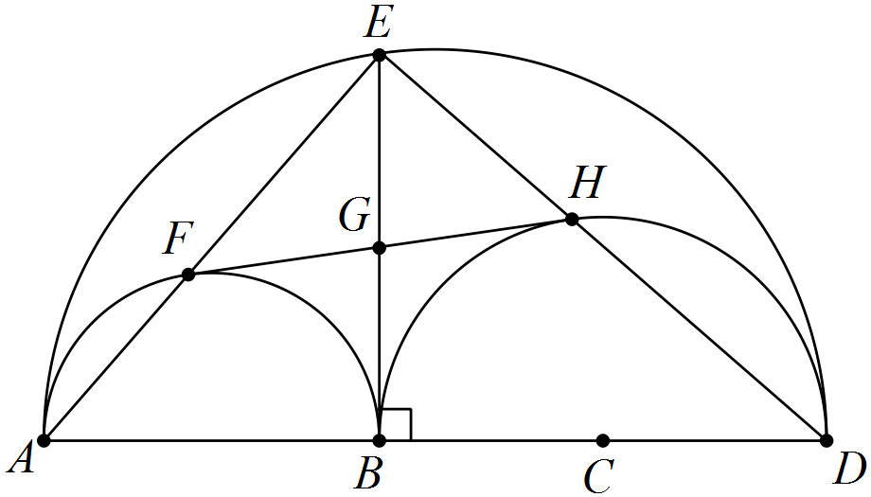

(a) Explain why BFEH is a rectangle. (2 marks)

|  |
| --- |
| **Solution** |
|  |
| **Specific behaviours** |
| ✓ uses angle in semicircle  ✓ explains three angles are right, and so is a rectangle |

(b) Prove that  and  are congruent. (3 marks)

|  |
| --- |
| **Solution** |
|  |
| **Specific behaviours** |
| ✓ uses radii  ✓ uses diagonals bisecting  ✓ uses common side |

(c) Deduce that line FH is a tangent to the semicircle with diameter BD. (2 marks)

|  |
| --- |
| **Solution** |
|  |
| **Specific behaviours** |
| ✓ uses corresponding angles  ✓ deduces must be tangent |

Additional working space

Question number: _________

Additional working space

Question number: _________

© 2016 WA Exam Papers. Perth Modern School has a non-exclusive licence to copy and communicate this paper for non-commercial, educational use within the school. No other copying, communication or use is permitted without the express written permission of WA Exam Papers.